- Correctly label the parts of this diagram, which shows the human respiratory system. (8 marks)
- In the diagram, label where you think the epiglottis is located. (2marks)
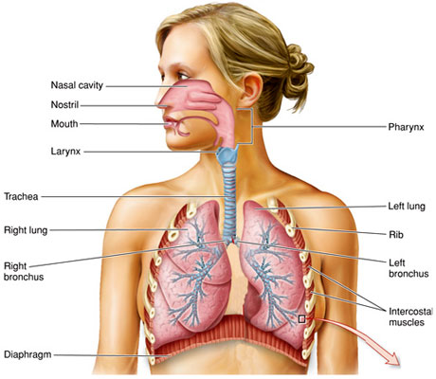

- Match the part of the respiratory system to its function.
Larynx | Also called the windpipe is a straight tube about 12cm long. It allows air to pass freely to and from the lungs
Diaphragm | It is also called the Adam’s apple and contains your vocal chords. When air blows over these it makes sounds.
Rib cage | Is the structure which protects the lungs and other internal organs, moves up and down during breathing.
Bronchus | This forms the floor of the thorax, it is very important in breathing.
Trachea | It spits into smaller tracks each of which goes into each lung.
(5 marks)
- Complete the table below: (8 marks)
Inhalation | Exhalation
Diaphragm moves ________________. Ribs raised ________ and ___________. | Diaphragm moves upwards. Ribs ____________ down and _________.
This movement causes the volume of the ribcage to _____________ and air pressure in the lungs _________________. | This movement causes the ___________ of the rib cage to decrease and _________________ inside the lungs _______________.
Air is _________ _________ your lungs. | Air is forced out of your lungs.

- In the diagram below which shows the bell jar model, state what the Y-Tube, Balloon and the Rubber Sheet represents in the human respiratory system. (3 marks)
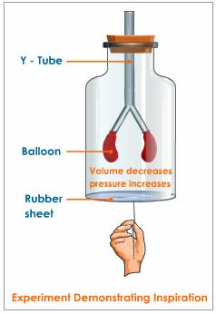
Y- Tube - __________________________________
Balloon __________________________________
Rubber Sheet __________________________________

- How does the bell jar demonstrate breathing?
____________________________________________________________________________________________________________________________________________________________________________________________________________________________________________________________________________________________________________________________________________________________________________________________________________________________________________________________________________________
(5 marks)

