What is breathing?
Breathing is the process by which air (oxygen) enters our body (inhalation) in order for bodily process to occur, and the way in which waste gaseous material (carbon dioxide) is exited (exhalation)

Diagram of the Respiratory System
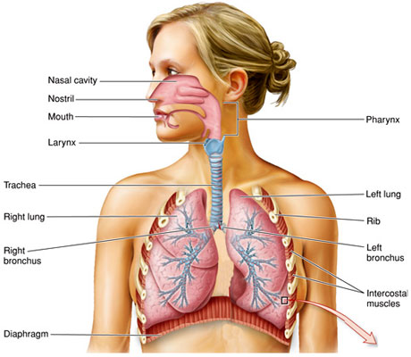
Epiglottis

Function of the Parts of the Respiratory System
Part of the Respiratory System | Function
Pharynx | Also known as the throat belongs to both the alimentary and respiratory systems. In the respiratory system the air passes from the nasal cavity to the windpipe and then to the lungs.
Larynx | Air enters the larynx before going down the windpipe. It is also called the Adam’s apple. The larynx contains your vocal chords. When air blows over these it makes sounds.
Epiglottis | A flap of skin which drops over the opening of the larynx. This stops any food from going down your windpipe. Did you know this is why we can’t breathe and swallow at the same time?
Trachea | Also called the windpipe is a straight tube about 12cm long. It allows air to pass freely to and from the lungs
Lungs (right and left) | The main organs of the respiratory system. It is the area where gaseous exchange occurs.
Ribs (rib cage) | The ribcage is the structure which protects the lungs and other internal organs, moves up and down during breathing.
Bronchus | The trachea spits into bronchi (plural), one bronchus goes to each lung.
Intercostal Muscles | Are several groups of muscles that run between the ribs, and help form and move the chest wall. The intercostal muscles are mainly involved in the mechanical aspect of breathing. These muscles help expand and shrink the size of the chest cavity when you breathe.  Contains the external and internal intercostal muscles.
Diaphragm | This forms the floor of the thorax, it is very important in breathing.

The process of breathing
When we breathe there are movements which take place in our chest. The chest works like a pair of bellows, sucking air in and then forcing it out. However, it is the muscles between our ribs and in our diaphragm which cause the lungs to work. Breathing can be divided into two parts: inspiration (inhalation) and expiration (exhalation).
Inhalation - this is the sucking of air into the lungs, and is brought about by the chest expanding.
Exhalation- this is the forcing of air out of the lungs, and is brought about by the chest contracting.
What happens during inhalation and exhalation?
Inhalation | Exhalation
Your intercostal muscles contract. This causes the ribs to move upwards and outwards. | Your intercostal muscles relax.  This causes the ribs to move downwards and inwards.
The muscle in your diaphragm contracts. Your diaphragm flattens. | The muscle in your diaphragm relaxes. Your diaphragm bulges upwards.
These processes increase the volume of your thorax. The pressure inside your thorax decreases as this pulls on the lungs and they expand. | These processes decrease the volume of the thorax. The pressure inside your thorax increase, as this squeezes the lungs.
Air is sucked into your lungs. | Air is forced out of your lungs.

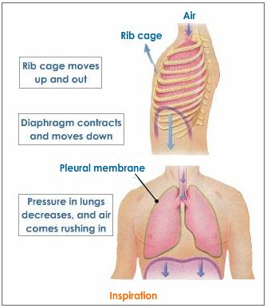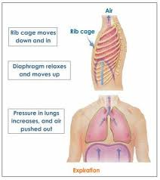
The bell jar model of the lungs
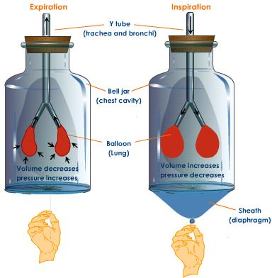
The above shows how the bell jar model works. The chest cavity itself represents the chest cavity. When the bell jar is stationary the balloons which act as the lungs look deflated this is because the bell jar is a closed system and the pressure in the jar is high whilst the volume is low. This is how the lung may be represented during expiration. However when the sheath is pulled, the volume increases and the pressure decreases which is typical of what occurs during inspiration.

Additional Notes:
